COOL SHOW TITLE
Sponsorship Agreement Outline
Updated on Friday, September 7, 2017

Fall 2013

Show Information

Title: Cool Show Title

Producers: Producer Smith, Producer Johnson

Associate Producer: Some other guy

Genre: Drama, Action

Format: Narrative

Synopsis: After a science experiment gone wrong, Ithaca College has created a scenario feared by many: the Zombie Apocalypse. Closed off from the outside world, many have fallen, but a group of students struggle to survive while trapped within the boundaries of the IC campus. Together, they scavenge for resources, fight the good fight, and strive for a cure to save them all.

[SHOW PICTURE]

Expected Number of Crew Members: 35

Expected Number of Main Cast Members: 10

Expected Number of Extras: TBD (will depend on scenes being shot)

Number of Planned Film Shoots: 22

Marketing Plan

Would include: Standard visual/auditory acknowledgment, social media marketing

Standard Visual/Auditory Acknowledgment

Sample visual acknowledgment:

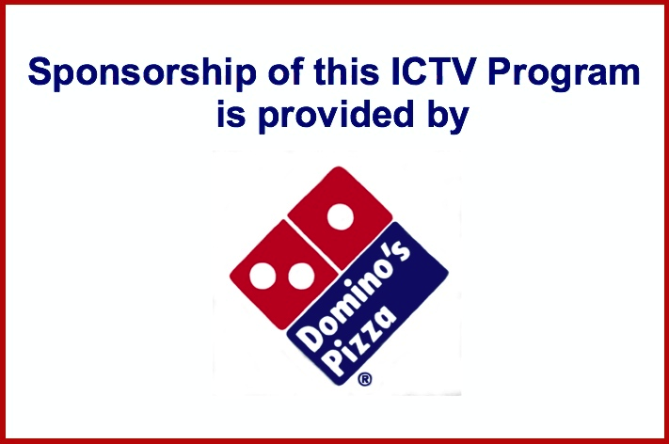

Details:

- Visual/auditory acknowledgment would occur at the beginning and end of every episode

  - Potentially during commercial breaks

- Auditory aspect of acknowledgment would be recorded by “Ithapocalypse” cast/crew

- Per request, visual acknowledgment could include Domino’s Pizza’s business address and contact information

Social Media Marketing

Details:

- Would consist of posts on the “Ithapocalypse” Facebook page and Twitter account

  - Posts/tweets would be weekly and would link to the Domino’s Pizza social media accounts

- Posts would specifically link to an order page, whether it be Domino’s, GrubHub, etc.

- Would also consist of posts by the “Ithapocalypse” cast and crew’s personal social media accounts

  - Includes Facebook, Twitter, Foursquare, Instagram, Google+, etc.

  - Posts/tweets/check-ins/etc. would appear multiple times a week and would link to Domino’s Pizza social media accounts

Sample Post:

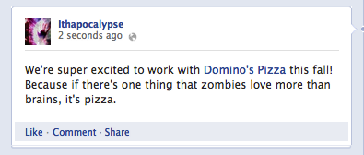

Sample Tweet:

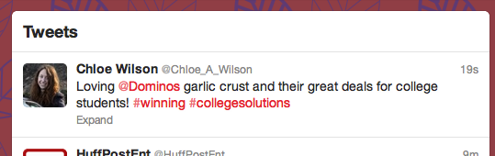
Craft Services Request

Orders Per Week: Two

Times/Dates of Orders: Wednesday evening, Saturday afternoon

Average Amount of Cast/Crew On-Set Per Day: 25

Requested Food Per Order: Four large pizzas, one bottle of soda

- Plates and napkins would be ideal, but not necessary

Weekly Totals: Eight large pizzas, two bottles of soda

- Each pizza is allowed one topping

Number of Shoots That Require Craft Services: 22

Planned Dates of Orders:

- September 12

- September 15

- September 19

- September 22

- September 26

- September 29

- October 3

- October 6

- October 10

- October 13

- October 17

- October 24

- October 27

- October 31

- November 3

- November 7

- November 10

- November 14

- November 28

- December 1

- December 5

- December 8

Plan of Delivery: Order would be placed through an “Ithapocalypse” crew member and an “Ithapocalypse” crew member would drive to the Domino’s Pizza location to pick up order

