Mobile ENPS Guide

Mobile ENPS is a less complex version of the program that is accessible from any computer. The website is best for adding scripts to your rundown. You cannot make a new rundown, adjust your rundown order, or add a line in this program. Those tasks must be done on a Greenroom or Newsroom computer.

- To access the application, go to https://mobenps.ithaca.edu/enpswebaccess3/, and log in with your Netpass username and password.
- After logging in, you’ll have a list of rundowns in the ICTV folders to your left. Click on the rundown you want to access
- Your rundown will appear on the screen. Clicking on the story slug name will open the script.

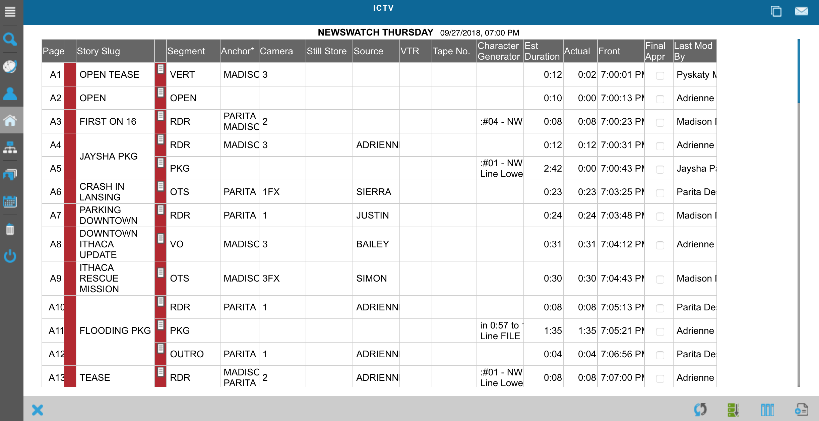
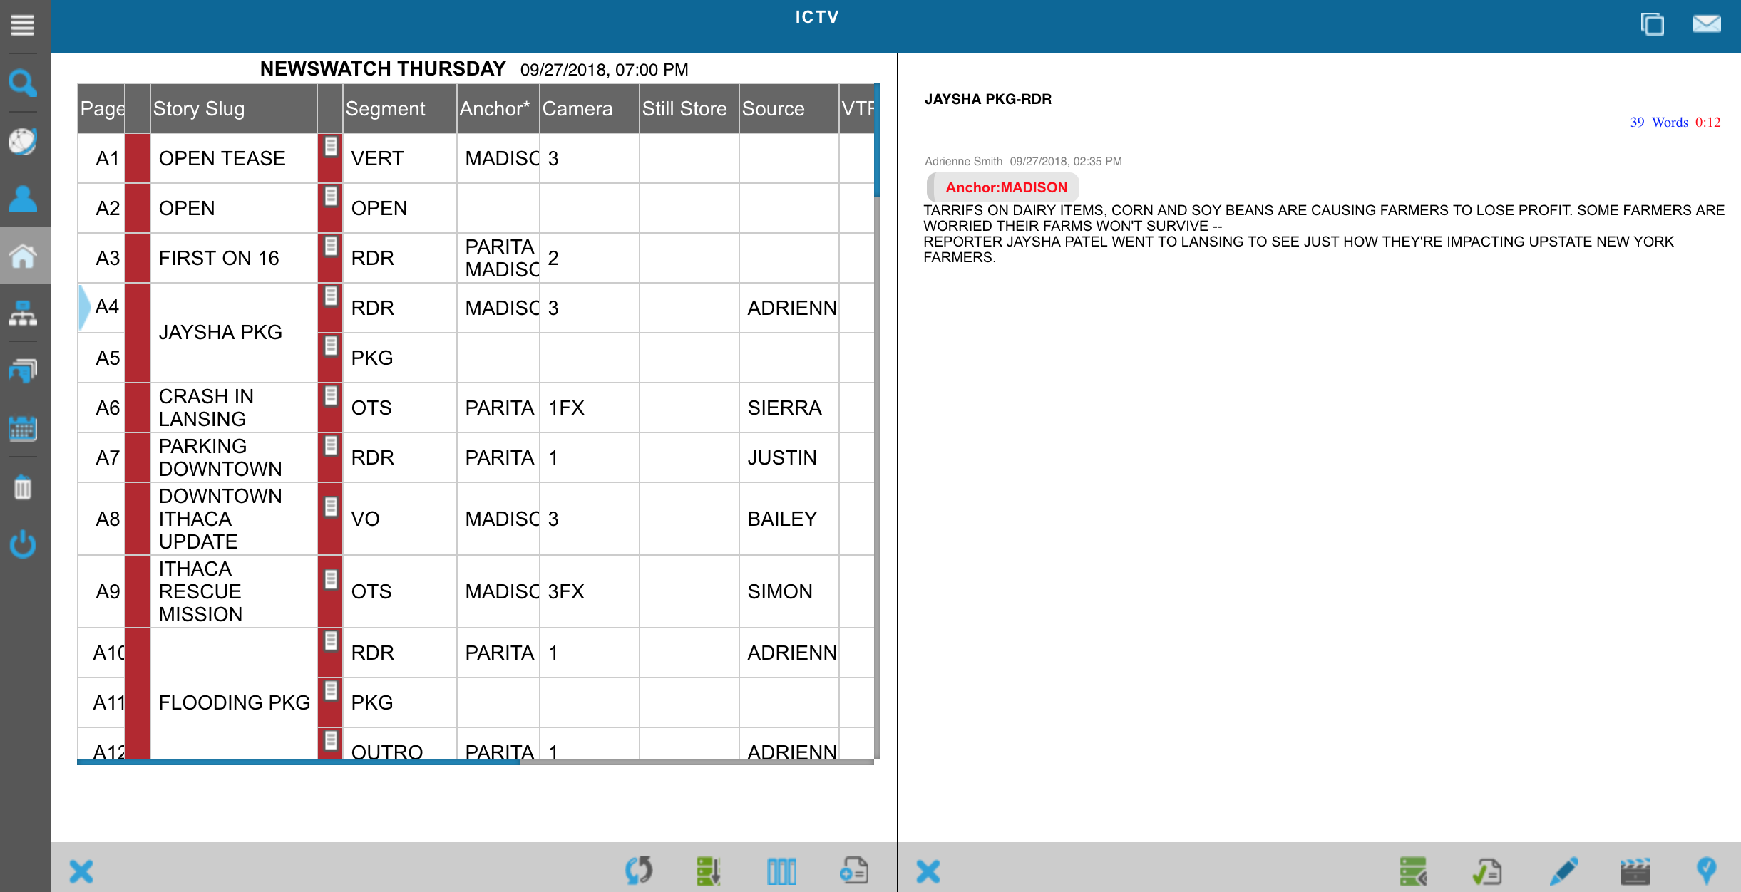

- To edit the script, click the pen/pencil button in the bottom right corner. This will allow you to edit the script and the slug name. To add a production command (TAKE, ANCHOR, etc.), click the megaphone in the bottom right corner, and select the command you’d like to insert. Do not use the CG function to add keys. Those must be done on a desktop computer with the full ENPS software. Remember to click SAVE when you’re done.

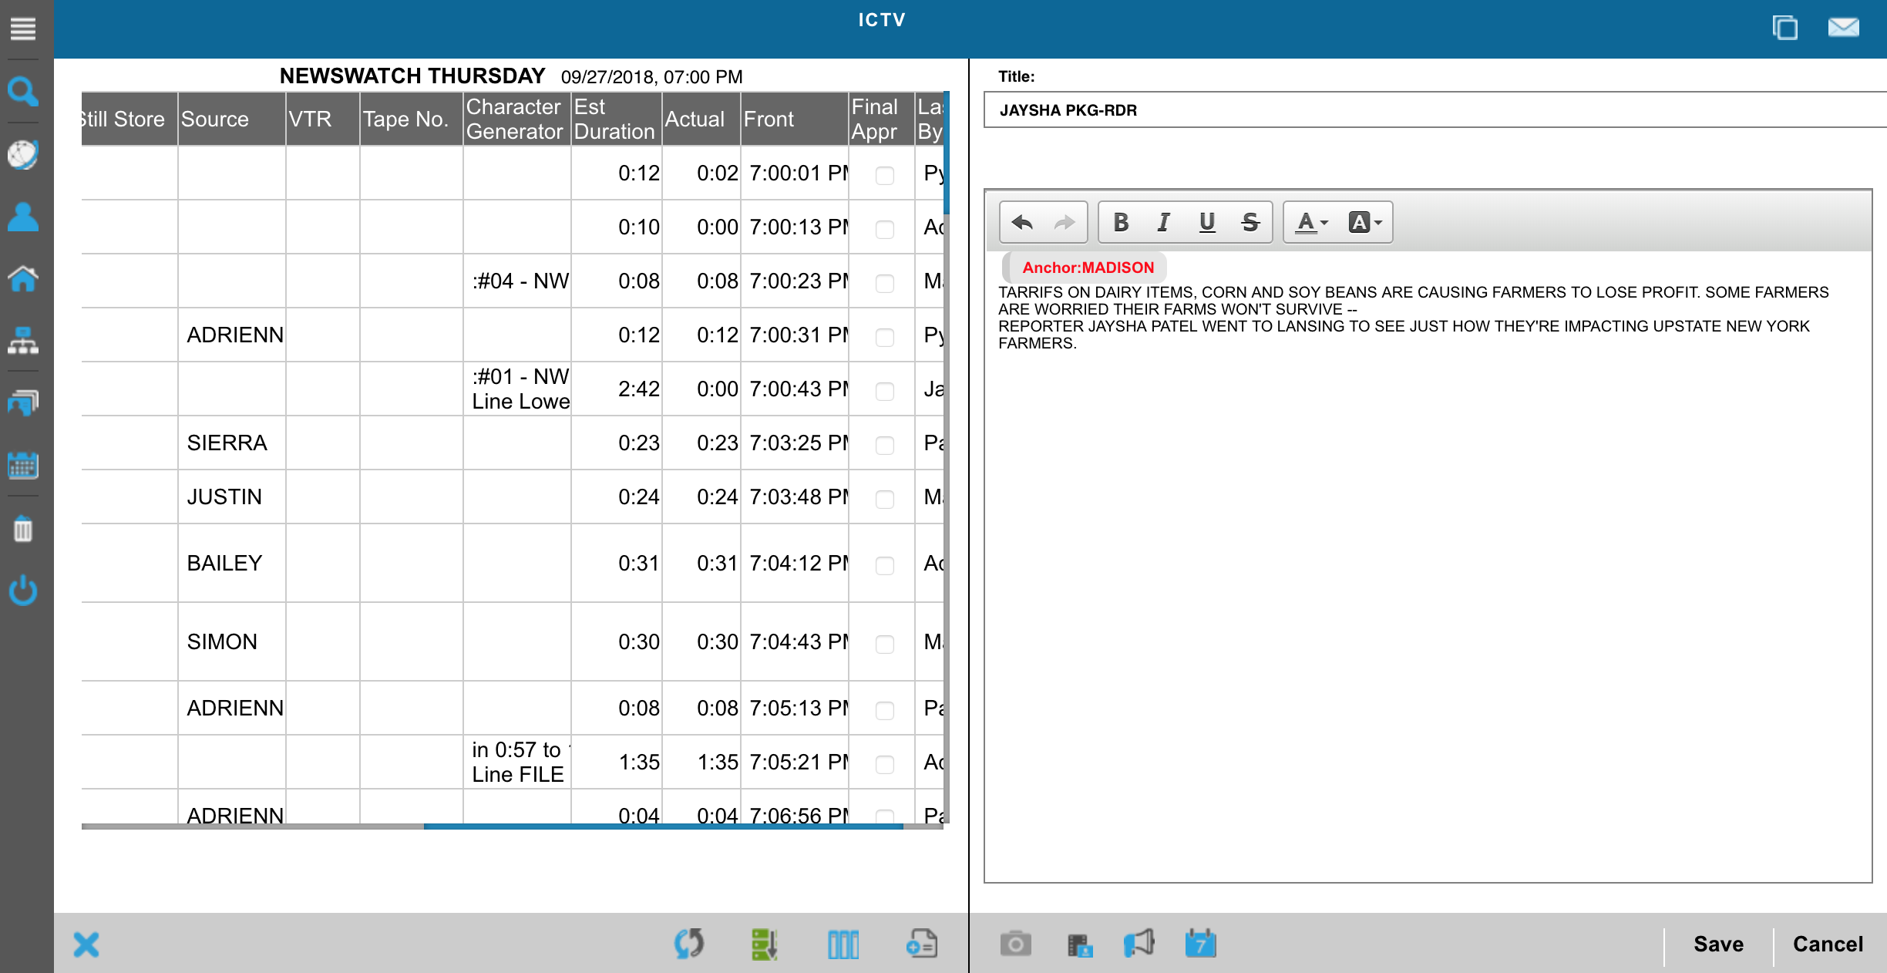

Any questions? Email Michael Pyskaty (news@ictv.org) for an answer.

