Preparing File Submissions for ICTV

Settings
Step 1. Project Settings
-When opening a new project in Adobe Premiere, set your project location and your scratch disks to your show hard drive and not the computer you are editing on.
-When setting up your project, make sure that all of your footage is downloaded to your hard drive and not coming directly from the server or the computer you are editing on.

Step 2. Sequence Settings
Adobe Premiere Pro does NOT prompt you to create a new sequence when you create a new project. Therefore you must create a new sequence by either:

File → New → Sequence OR Keyboard shortcut : ⌘​N
When prompted, set the sequence settings to the following settings:
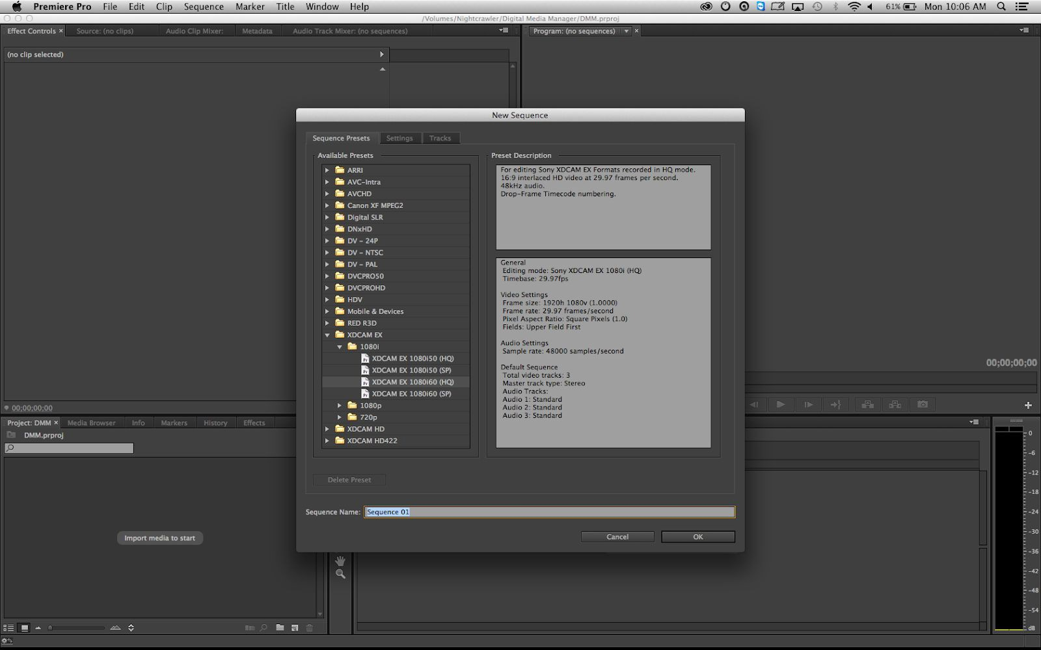
XDCAM EX 1080i60 (HQ)

Editing
Step 3. Importing your clips to the sequence

Once you have created your project and sequences you can bring your clips into Premiere Pro and into your sequence.

NOTE: The following window may appear when importing footage. MAKE SURE YOU CLICK “KEEP EXISTING SETTINGS”
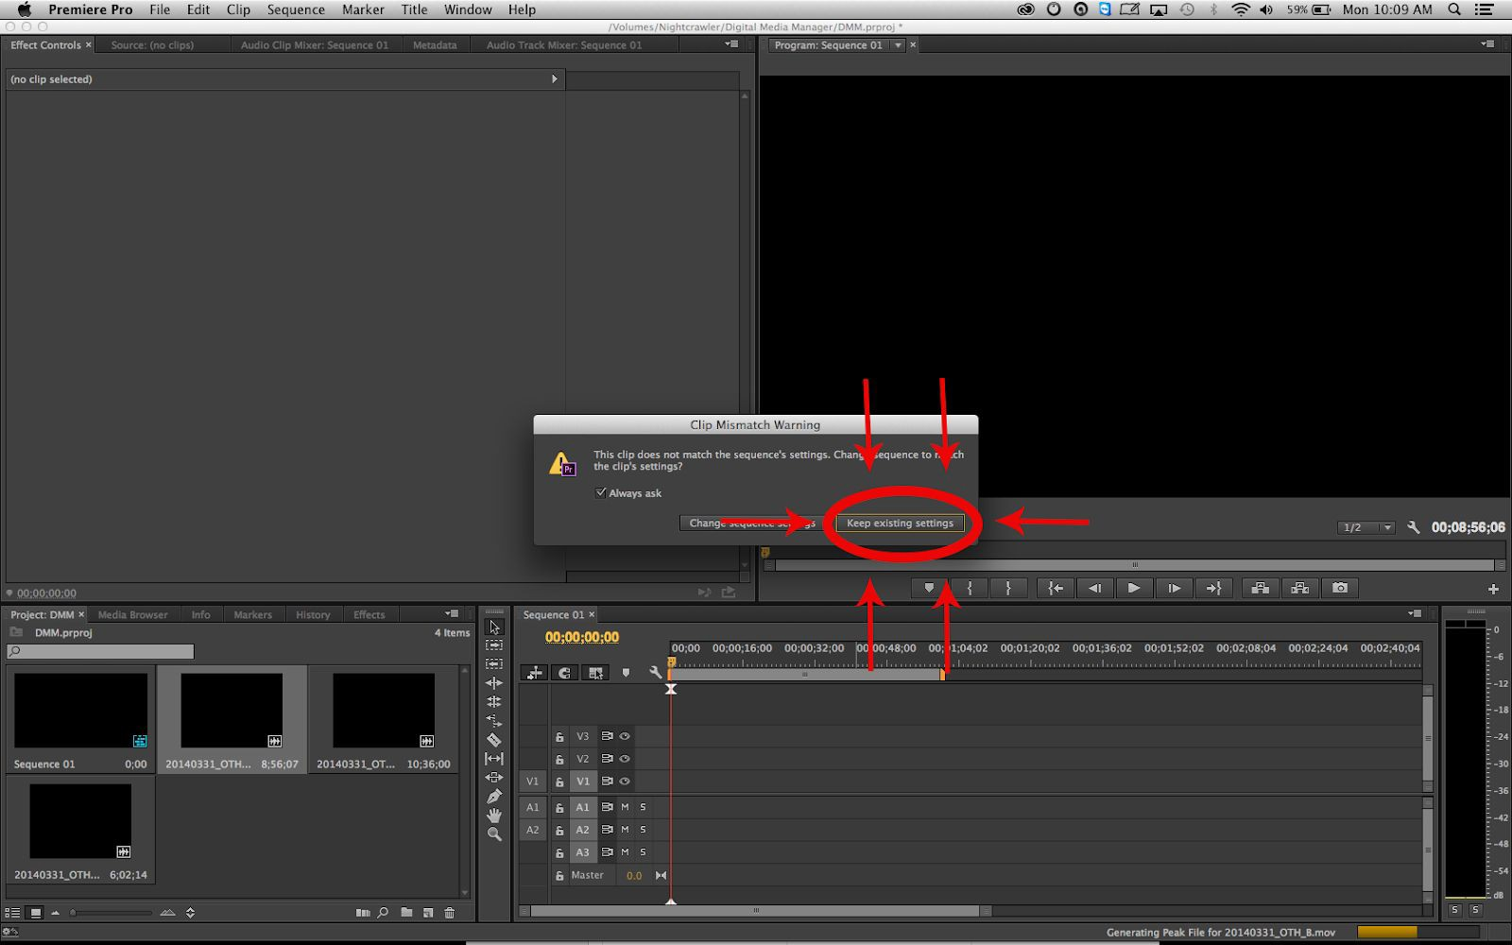

NO LETTERBOXING!!!! Since we are working with 16x9 content, there should never be black letterboxing bars. If your footage appears stretched or does not fill the frame, use the scale and position controls under the Effects Controls tab to correct it.

Please make sure all lower thirds are within the title safe area.

Step 5. Editing for time
Make sure that the length of your show matches what it needs to be in order to air. Half Hour Shows are 28:30 with breaks. Without breaks...
- Breaks / 1 Block - 28:30
- Breaks / 2 Blocks - 27:00
- Breaks / 3 Blocks - 25:30
- Breaks / 4 Blocks - 24:00
Hour Long Shows are 58:30 with breaks. Without breaks...
6 Breaks / 7 Blocks - 51:00
-All breaks are 90 seconds long.
Step 6. Normalize Audio:
- Right click on audio track
- Select Audio Gain
- Select Normalize All Peaks to:
- Type in -12 into text box next to dB
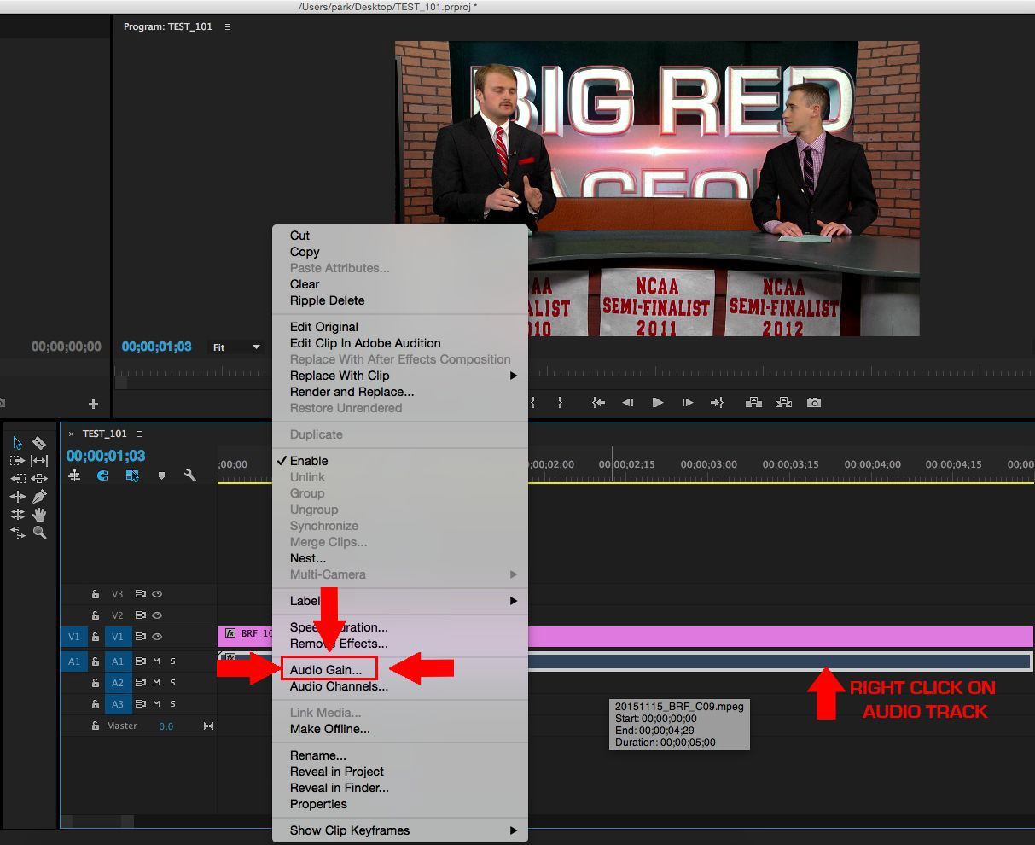
- Click OK
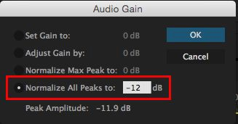

There are no other steps to normalizing audio. If you do anything else with audio after normalizing, you risk the final export being softer/louder than it needs to be.

Scrub through your project and make sure that the audio levels are consistently close to -12dB without exceeding it. If they aren’t, undo the normalization, adjust the volume of any abnormal clips, and try again.

Exporting
All ICTV shows must deliver their content in separate blocks and as a complete Web File (with all commercial breaks removed).
Step 7. Exporting Blocks
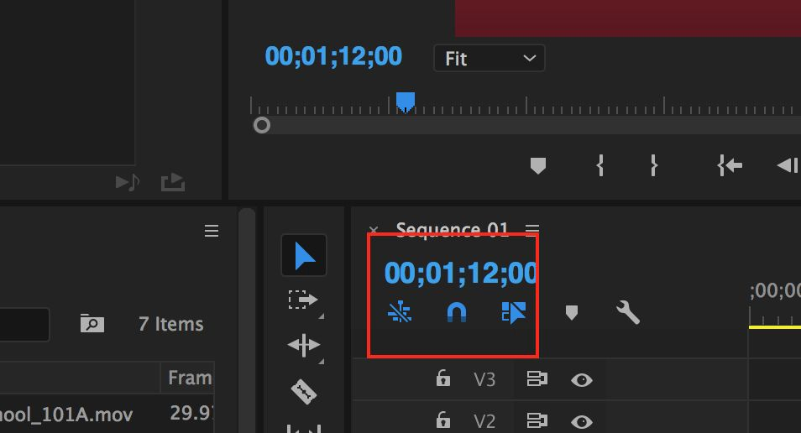
Make sure snapping is turned on by pressing “N” or clicking the magnet on your sequence. It will turn blue when it’s on. Mark the in (Press “I”) and out (Press “O”) points for your first block.

With the timeline window still selected, go to:
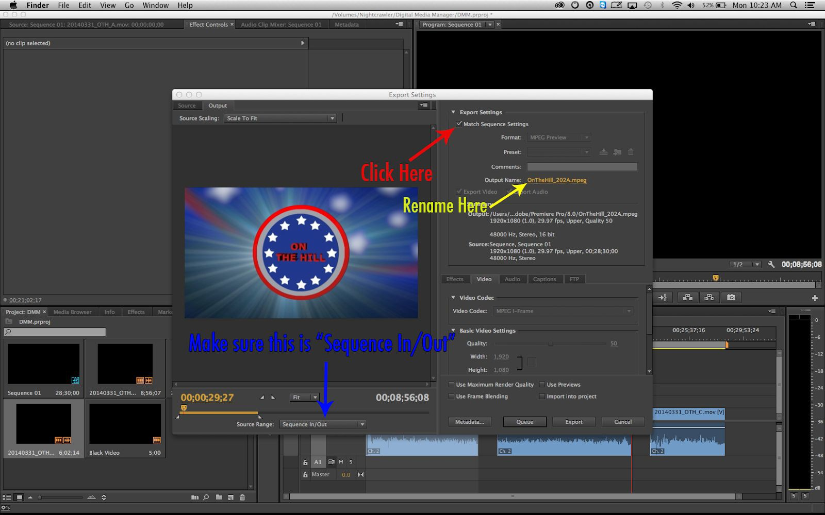
File → Export → Media.

Directly under Export Settings click “Match Sequence Settings” then rename your clip by clicking the blue text next to “Output Name”. Make sure the Source Range (found under the preview window) is set to “Sequence In/Out”

Naming Convention
All Blocks must follow this naming convention:
ShowName_(SeasonNumber)(EpisodeNumber)(BlockLetter) Example: BigRedFaceoff_1001A
Repeat these steps for each block of your episode. NOTE: You can “Queue” each block instead of exporting them. This will allow you to render and export all of your blocks at once at the end.

Step 8. Exporting Web You will need to go back and export the entire episode together at this point.

Make sure there is no black space in-between blocks, and then set IN and OUT points at the beginning and end of the episode.

Then repeat: with the timeline window selected, go to: File → Export → Media.
Once again, rename your clip by clicking the blue text next to “Output Name”.

Naming Convention
All Web Files must follow this naming convention:
ShowName_(SeasonNumber)(EpisodeNumber)_WEB Example: BigRedFaceoff_1001_WEB

Export Settings

Click the drop-down menu next to “Format” and select the H.264 format.

The settings for web episodes are available as a downloadable web preset at ictv.org/resources. This preset is also available on most computers in the green room.

To install the preset, click on the folder icon next to “Preset” and find the file you downloaded from the website: ICTV WEB OFFICIAL.epr

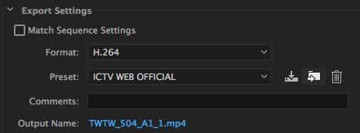
If the preset is already installed, simply click the drop-down menu next to “Preset” and select “ICTV WEB OFFICIAL”.

If you cannot or wish not to use the preset, the settings for web exports are as follows:

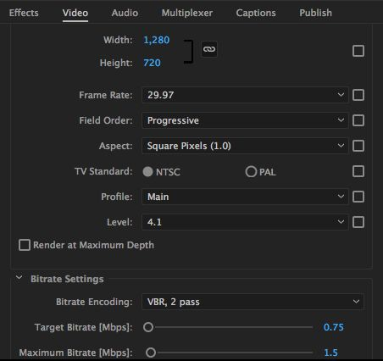
VIDEO:
Width: 1280, Height: 720,
Frame Rate: 29.97,
Field Order: Progressive, Aspect: Square Pixels (1.0), TV Standard: NTSC,
Profile: Main, Level: 4.1,
Target Bit Rate: 0.75, Max Bit Rate: 1.5, Encoding: VBR (2 pass)

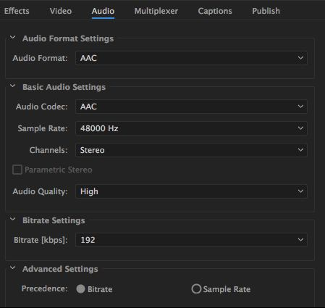
AUDIO:
Format: AAC,
Sample Rate: 48000 Hz, Channels: Stereo, Audio Quality: High,
Bit Rate: 192, Precedence: Bit Rate

With few exceptions, your final WEB file should be no larger than 500MB in size.

Step 8. Exporting from Adobe Media Encoder
If you have been pressing Queue instead of export, open Adobe Media Encoder and begin the Render Queue by hitting the green play button at the top.
Step 9. Creating a still:
Go to the frame you want to use as your screenshot in your timeline. Click the camera button below the record monitor (shortcut Shift-E). Change Format to JPEG, and save the image with the following naming convention:
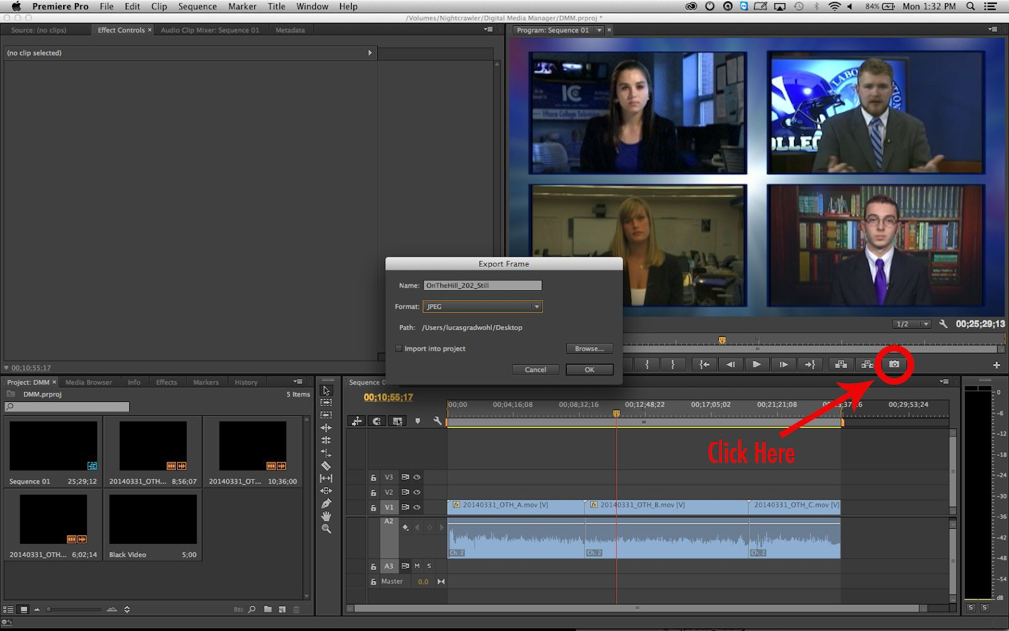
ShowName_(SeasonNumber)(EpisodeNumber)_STILL Example: BigRedFaceoff_1001_STILL

Submitting Episodes
Episodes are submitted to the ICTV Directory on the Parkstor Server which is located on all of the desktops of the computers in the Green Room. Within that directory is an “ICTV” folder. From there…
- BLOCKS go to your show folder within the “Block Submissions” section.
- WEB files and STILLS go to your show folder within the “WEB SUBMISSIONS” section.

Connecting to Parkstor:
- One can connect to the PARKSTOR from almost any Mac computer in Park by connecting to “smb://192.168.1.150” through Finder.

An episode is not considered submitted until the Submission Form is filled out. This can be accessed by going to ictv.org/submit and filling out the form with a title, description, and addition information.

DO NOT use your episode number as your title. DO NOT use the date of air as your title unless you has been approved to do so. Be as creative with your metadata as you are with the video content itself.

A FULL SUBMISSION means that you:
- Exported the episode in the right formats
- Placed the video file and thumbnail in the appropriate submission folder
- Filled out the submission form with the appropriate metadata

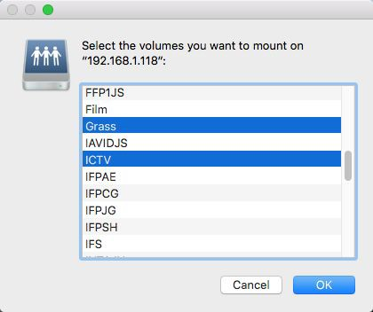
HOW TO ACCESS THE ISOLON

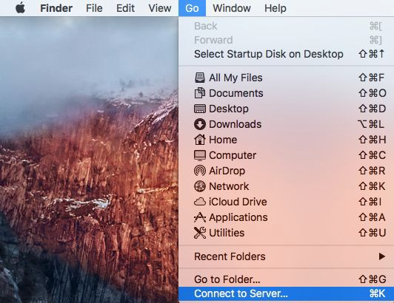
If the ICTV and/or Grass directories are not on the desktop or you are on a different computer in Park, reconnecting to the Isolon server can be done as follows:

At the top of the screen, click “Go”, then “Connect to Server…” (shortcut Command-K)

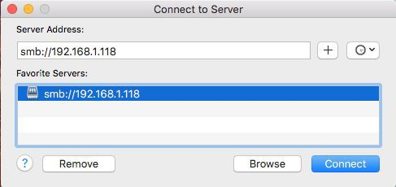
The server you need to connect to is smb://192.168.1.118. Computers in the Green Room have this server saved as a favorite.

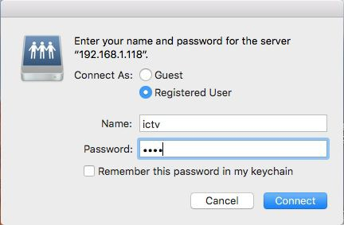
If asked, username and password are both “ictv”, no caps or quotes.

Select “Grass” and “ICTV” from the menu. “ICTV” is the directory that leads to the Submissions folder, “Grass” is used for file transfers to and from the K2 server.

SUBMISSION CHECKLIST

“Why did my episode get rejected?”

Please review the following list BEFORE submitting an episode to help prevent rejected submissions.

Editing and Content Checks: | ✔
Blocks fade up from and to black
Audio is normalized to -12db
The “Copyright ICTV [YEAR]. All Rights Reserved” key is up for at least 3 seconds at the very end of the episode.
29.97 frames per second (NOT 25)
There are no calls to action, curses, innuendos, or obscene gestures.
Any content which isn’t your own is credited, including ICTV file
footage.
For 30-minute shows:
- Break / 1 Block Shows must be 28:30
- Break / 2 Block Shows must be 27:00
- Break / 3 Block Shows must be 25:30
- Break / 4 Block Shows must be 24:00 For 1-hour shows:
6 Break / 7 Block Shows must be 51:00
Export: | ✔
Export each BLOCK as MPEG file
Export full sequence as H.264 MP4 file using WEB settings
STILL is saved via the screenshot feature in Premiere
Submission: | ✔
BLOCKS are submitted to your show folder in the “BLOCKS” section of the ICTV Isolon directory.
WEB files and STILLS are submitted to your show folder in the
“WEB” section of the ICTV Isolon directory.
Submission Form is filled out at ictv.org/submit.

